Spearman rank correlation: EURUSD and EURGBP
Method 02 / daily log returns / Alpari D1 full available history

Study setup
Logical pair: EURUSD , EURGBP
Broker symbols: EURUSD_i , EURGBP_i
Snapshot: 2026-11-03_majors_alpari_D1
Timeframe: D1
Matched return window: 1999-01-06 to 2026-11-02 (UTC bar dates)
Matched return count n: 7183
Dropped unfinished last bar dated 2026-11-03 UTC after a tick-volume check against the prior complete day.
Complete matched rows (CSV): EURUSD-EURGBP_Spearman_D1.csv
Complete matched rows (HTML table): EURUSD-EURGBP_Spearman_D1_data.html

Method carried forward
Spearman rho is Pearson correlation on the ranks of matched daily log returns of close, ln(close_t / close_t-1), in the broker quote direction. Ties use average ranks. Quotes are not inverted. rho is symmetric under swap of the two symbols. rho = 0 means no consistent rank-order link in this sample; it does not mean no link of any kind. The score is not a cause, not a lead, and not a trading signal. Daily rows are not independent draws, so the two-sided p-value and approximate Fisher interval are reported and treated as secondary to rho. Same-sample Pearson r is shown only as a side check; a large rho minus r gap can flag outliers or a non-straight link.

Results
Spearman rho: 0.430454
Two-sided p-value: 0
Approximate 95% Fisher interval: [0.411423, 0.449110]
Same-sample Pearson r: 0.439899
rho minus r: -0.009445

Conclusion
Over 7183 matched daily log-return rows for EURUSD and EURGBP (broker quote directions unchanged), Spearman rho is 0.4305 (positive, moderate rank-order association in this sample). Approximate 95% Fisher interval: [0.4114, 0.4491]. Same-sample Pearson r is 0.4399 (rho minus r = -0.0094). Two-sided p under the usual independent-ranks model is 0; that model does not match linked daily FX returns, so treat p as secondary. This does not establish cause, lead-lag, or a lasting trading rule.

Charts
Daily closes

Daily log returns
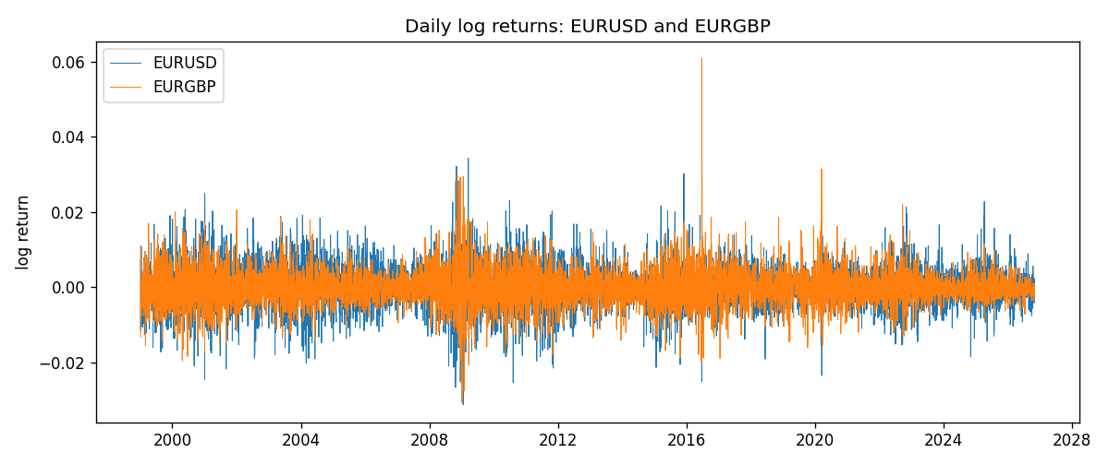
Log-return scatter
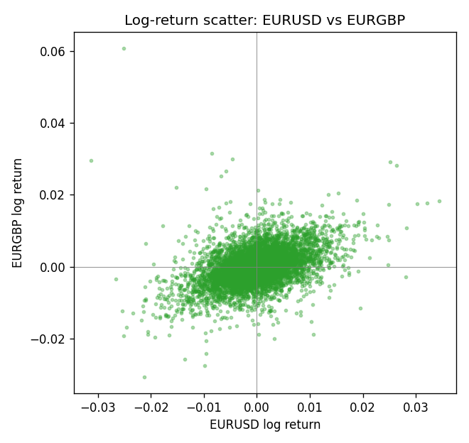
Rank-rank scatter
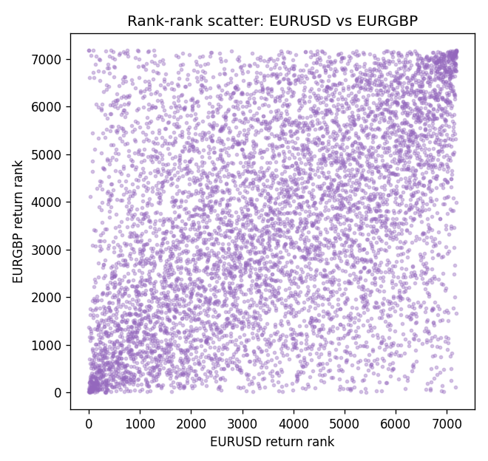

Data report
Every matched row that entered Spearman rho is stored in the sibling CSV named EURUSD-EURGBP_Spearman_D1.csv. That file is the complete data archive for redrawing charts. Embedding all rows as a Word table is impractical at this length; the Word file holds the column list, column summaries, and the first and last 15 matched rows.
Columns: time, EURUSD_open, EURGBP_open, EURUSD_high, EURGBP_high, EURUSD_low, EURGBP_low, EURUSD_close, EURGBP_close, EURUSD_tick_volume, EURGBP_tick_volume, EURUSD_spread, EURGBP_spread, EURUSD_real_volume, EURGBP_real_volume, EURUSD_log_return, EURGBP_log_return
Column summaries (matched calculation rows)
column | count | mean | std | min | 25% | 50% | 75% | max
EURUSD_open | 7183 | 1.1815763 | 0.15079461 | 0.8272 | 1.08621 | 1.16623 | 1.29409 | 1.5995
EURGBP_open | 7183 | 0.78698868 | 0.09663692 | 0.5734 | 0.6877 | 0.83389 | 0.86522 | 0.9769
EURUSD_high | 7183 | 1.1867072 | 0.15139096 | 0.8326 | 1.09029 | 1.17134 | 1.29941 | 1.6038
EURGBP_high | 7183 | 0.79006638 | 0.09701205 | 0.5789 | 0.6897 | 0.8369 | 0.8681 | 0.9799
EURUSD_low | 7183 | 1.1765677 | 0.15011491 | 0.8227 | 1.08209 | 1.16259 | 1.288515 | 1.5865
EURGBP_low | 7183 | 0.78428899 | 0.09645396 | 0.5682 | 0.6857 | 0.83166 | 0.86287 | 0.9661
EURUSD_close | 7183 | 1.1816163 | 0.15076829 | 0.8267 | 1.086135 | 1.16619 | 1.2941 | 1.5997
EURGBP_close | 7183 | 0.78703222 | 0.09663758 | 0.5735 | 0.6878 | 0.83395 | 0.86536 | 0.977
EURUSD_tick_volume | 7183 | 103246.15 | 173560.03 | 218 | 9420.5 | 52790 | 99596.5 | 1471626
EURGBP_tick_volume | 7183 | 87133.93 | 145499.42 | 154 | 6594.5 | 44358 | 81413 | 1424684
EURUSD_spread | 7183 | 19.326744 | 16.542159 | 0 | 8 | 12 | 20 | 50
EURGBP_spread | 7183 | 21.324655 | 19.119277 | 0 | 4 | 13 | 40 | 50
EURUSD_real_volume | 7183 | 4.0347326e+10 | 1.669497e+11 | 0 | 0 | 0 | 0 | 3.6149665e+12
EURGBP_real_volume | 7183 | 2.7872287e+10 | 1.3521454e+11 | 0 | 0 | 0 | 0 | 3.5726265e+12
EURUSD_log_return | 7183 | -5.81e-06 | 0.0057996 | -0.03123819 | -0.00324487 | 0 | 0.00325442 | 0.03433183
EURGBP_log_return | 7183 | 2.227e-05 | 0.00487305 | -0.03067367 | -0.00262314 | -9.879e-05 | 0.00256076 | 0.06075387
First 15 matched rows (selected columns)
time | EURUSD_close | EURGBP_close | EURUSD_log_return | EURGBP_log_return | EURUSD_tick_volume | EURGBP_tick_volume
1999-01-06 | 1.1623 | 0.7019 | -0.011547966 | -0.013303338 | 4828 | 2635
1999-01-07 | 1.1712 | 0.7097 | 0.0076280636 | 0.011051402 | 5076 | 2464
1999-01-08 | 1.1585 | 0.7062 | -0.010902799 | -0.004943862 | 5120 | 3132
1999-01-11 | 1.1503 | 0.7053 | -0.007103287 | -0.0012752393 | 4960 | 2418
1999-01-12 | 1.1555 | 0.7077 | 0.0045103728 | 0.0033970309 | 5248 | 2670
1999-01-13 | 1.1681 | 0.708 | 0.010845346 | 0.00042381861 | 6623 | 2612
1999-01-14 | 1.1681 | 0.7066 | 0 | -0.0019793588 | 5472 | 2560
1999-01-15 | 1.1563 | 0.7012 | -0.010153245 | -0.0076715819 | 6529 | 3031
1999-01-18 | 1.1605 | 0.7017 | 0.0036256946 | 0.00071280921 | 4054 | 2461
1999-01-19 | 1.1603 | 0.7007 | -0.00017235436 | -0.0014261269 | 5595 | 2606
1999-01-20 | 1.1566 | 0.7021 | -0.0031939256 | 0.0019960086 | 5736 | 2341
1999-01-21 | 1.1601 | 0.7016 | 0.0030215416 | -0.00071240297 | 5230 | 2450
1999-01-22 | 1.1587 | 0.7004 | -0.0012075213 | -0.0017118406 | 4559 | 2600
1999-01-25 | 1.1552 | 0.6966 | -0.0030251979 | -0.0054402425 | 3774 | 2304
1999-01-26 | 1.1562 | 0.6962 | 0.00086527651 | -0.00057438255 | 5465 | 3025
Last 15 matched rows (selected columns)
time | EURUSD_close | EURGBP_close | EURUSD_log_return | EURGBP_log_return | EURUSD_tick_volume | EURGBP_tick_volume
2026-10-13 | 1.11965 | 0.84458 | 0.0037402957 | 0.00020130374 | 54238 | 30915
2026-10-14 | 1.11545 | 0.84553 | -0.0037582255 | 0.0011241873 | 62973 | 39105
2026-10-15 | 1.12172 | 0.84479 | 0.0056053107 | -0.00087557391 | 77110 | 45290
2026-10-16 | 1.12371 | 0.84307 | 0.0017724895 | -0.0020380844 | 61341 | 39309
2026-10-19 | 1.12086 | 0.84259 | -0.0025394633 | -0.00056950988 | 58324 | 38133
2026-10-20 | 1.12354 | 0.83957 | 0.0023881672 | -0.0035906254 | 52645 | 42542
2026-10-21 | 1.12318 | 0.83839 | -0.00032046717 | -0.00140647 | 49937 | 35843
2026-10-22 | 1.12139 | 0.83682 | -0.0015949606 | -0.0018743924 | 60304 | 44479
2026-10-23 | 1.11989 | 0.83751 | -0.001338521 | 0.00082421033 | 56197 | 37399
2026-10-26 | 1.11735 | 0.83762 | -0.0022706559 | 0.00013133309 | 52040 | 38735
2026-10-27 | 1.11272 | 0.83595 | -0.004152342 | -0.0019957343 | 56245 | 36303
2026-10-28 | 1.1152 | 0.83651 | 0.0022262927 | 0.00066967224 | 61037 | 36532
2026-10-29 | 1.11772 | 0.83553 | 0.0022571351 | -0.0011722209 | 73892 | 49261
2026-10-30 | 1.11644 | 0.83351 | -0.0011458446 | -0.0024205543 | 70119 | 44060
2026-11-02 | 1.11881 | 0.83426 | 0.002120569 | 0.00089940465 | 59416 | 43437

